Deep Hybrid Attention Framework for Underwater Clarity and Sea Cucumber Recognition

1.Sunil Naidu GR.,2. B Nitya Santoshini Reddy, 3. K Nikitha, 4. P Deepak
1 Assistant Professor, Department of Artificial Intelligence and Data Science, SJC Institute of Technology,Chikkaballapur, Karnataka, India
2 Student, Department of Artificial Intelligence and Data Science, SJC Institute of Technology,
Chikkaballapur, Karnataka, India
3 Student, Department of Artificial Intelligence and Data Science, SJC Institute of Technology,
Chikkaballapur, Karnataka, India
4 Student, Department of Artificial Intelligence and Data Science, SJC Institute of Technology,
Chikkaballapur, Karnataka, India

Email – Sunilnaidugr5464@gmail.com, nsanthoshini7@gmail.com, knikitha0708@gmail.com, deepakchintu1965@gmail.com

Abstract: One of the Most crucial species for preserving the equilibrium of marine ecosystems, sea
cucumbers are also regarded as one of the seafood commodities with the highest commercial value.
However, human population monitoring of sea cucumbers is time-consuming, imprecise, and
potentially risky for divers. Poor vision, color distortion, noise, and dif iculty spotting any objects are
just a few of the challenges unique to underwater media. This research proposes a real-time sea
cucumber detection method using YOLOv5 and an underwater image enhancement technique. In
actuality, picture augmentation significantly improves the detection outcomes. Deep Learning model that has been trained to recognize and count sea cucumbers from underwater images and
videos notifies users via email and SMS. The proposed method will improve automation, accuracy,and efficiency in marine monitoring applications.

Key Words: Sea Cucumber Detection, YOLOv5, Underwater Image Enhancement, Deep Learning, Object Detection, Marine Monitoring, Computer Vision

1. INTRODUCTION:
Sea cucumbers are soft-bodied marine creatures that play a major role in the stability of coral reef habitats and the cycling of nutrients.Due to heavy harvesting pressure brought on by their great commercial worth, particularly in Asian cuisine and traditional medicine, many species have seen population declines.Consistent, trustworthy monitoring is now necessary for effective conservation.
Due to their heavy reliance on divers, conventional survey methods are expensive, sluggish, and prone to observational mistakes. Underwater image-based evaluations are particularly difficult because of problems like poor lighting, color distortion, and diminished contrast, all of which make automated analysis difficult. Recent developments in deep learning have enabled the automated identification of aquatic organisms. In this work, we use the YOLOv5 detection framework in conjunction with preprocessing techniques intended to improve the quality and identification accuracy of underwater
imagery. Authorities can also get instant updates on sea cucumber observations thanks to the system's real-time alerts via email and SMS.

2. LITERATURE REVIEW:
Underwater object recognition using deep learning has been studied in several
investigation.Conventional methods fared badly in noisy underwater environments because they depended on manually created features and threshold-based segmentation. In difficult situations, Convolutional Neural Networks (CNNs) have greatly increased detection accuracy. YOLO has been widely employed for real-time object detection because to its efficiency and speed. YOLOv3 and YOLOv4 have been successfully used by researchers to detect marine creatures. According to recent research, YOLOv5 offers more accuracy at a lower computational cost. To increase image quality prior to identification, underwater image improvement approaches such deep learning-based dehazing, dark
channel prior, and histogram equalization have been employed. Nevertheless, very few systems
combine warning, counting, detection, and enhancement into one framework. The goal of this project
is to close this gap

3. OBJECTIVES / AIMS:
The following work is designed to develop a real-time sea cucumber detection system with the YOLOv5 deep learning model. It aims at enhancing underwater images for better visibility, detectingand counting sea cucumbers with high accuracy, and providing automated alerts via SMS and e-mail.This system further ensures the efficiency of monitoring and reduces human effort in marine surveys.

4. RESEARCH METHOD / METHODOLOGY:
The proposed methodology begins with the collection of underwatersea cucumber images from public datasets and real-time video sources. The collected data is manually annotated and divided into training and testing sets. An underwater image enhancement technique is applied to improve visibility by reducing haze and noise.The YOLOv5 deep learning model is then trained using the improved photos to recognize sea cucumbers accurately. For real-time detection and automatic counting, the trained model is evaluated on unseen photos and video streams.Finally, the detection results are transmitted to
users through SMS and Email alert systems for monitoring purposes.

5. FINDINGS / RESULTS:
The experimental results demonstrate that the proposed system is effective in detecting sea cucumbers in underwater images and videos. The application of underwater image enhancement significantly improved image clarity and detection accuracy. The YOLOv5 model achieved reliable performance with high precision and real-time detection capability. The system successfully counted the detected sea cucumbers and generated accurate SMS and Email alerts. Overall, the results confirm that the proposed approach is efficient and suitable for real-time marine monitoring applications.

6. DISCUSSION / ANALYSIS :
According to the investigation, enhancing underwater images is essential to raising the sea cucumber detecting system's performance. Low contrast and poor visibility decreased detection accuracy in the absence of augmentation. The use of the YOLOv5 model enabled fast and accurate real time detection even in challenging underwater conditions. The integration of automated counting and alert mechanisms further improved the practical usefulness of the system. These results confirm that the proposed approach is reliable and effective for real-world marine monitoring and
conservation applications.

7. RECOMMENDATIONS:
To further increase detection accuracy, using better underwater imaging equipment is advised. Adding photos from various marine habitats to the dataset can improve the model's resilience. To deal with extreme underwater conditions, sophisticated deep learning-based picture augmentation techniques might be incorporated. For wider uses, the system can be expanded to identify several marine species. Deploying the model on edge or embedded devicesissuggested
for real-time field monitoring.

8. LIMITATIONS:
The quality of underwater photos is a major factor in the system's performance, and high turbidity or dim lighting can lower detection accuracy. For the model to be trained effectively, a sufficiently large and well-annotated dataset is needed. For the SMS and email alert systems to work correctly, internet connectivity is required. Highly crowded underwater scenes with overlapping objects may potentially provide difficulties for the technology. Furthermore, sufficient computational power is needed for real-time deployment.

9. CONCLUSION / SUMMARY:
This project successfully developed an automated sea cucumber detection system using YOLOv5 and underwater image enhancement. The system effectively detects, counts, and notifies the number of sea cucumbers in real time. The integration of enhancement techniques improves detection accuracy in challenging underwater environments. The proposed system reduces human effort, increases monitoring efficiency, and contributes to sustainable marine resource management. It has strong potential for real-time marine surveillance and conservation applications.

10. Acknowledgment:
The authors would like to express their sincere gratitude to the project guide,
department faculty, and institution for their continuous support and guidance. Special thanksto all those who provided datasets and technical assistance for the successful completionof this project.

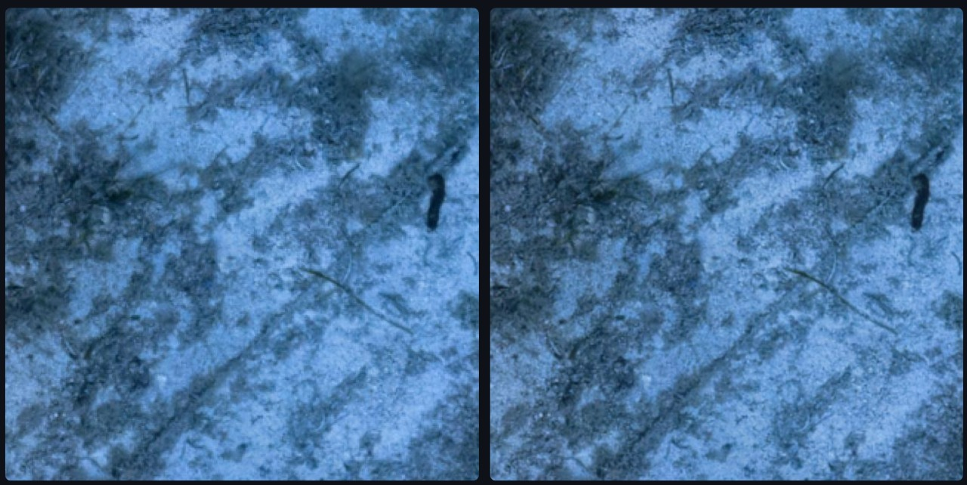

Fig: Enhanced output

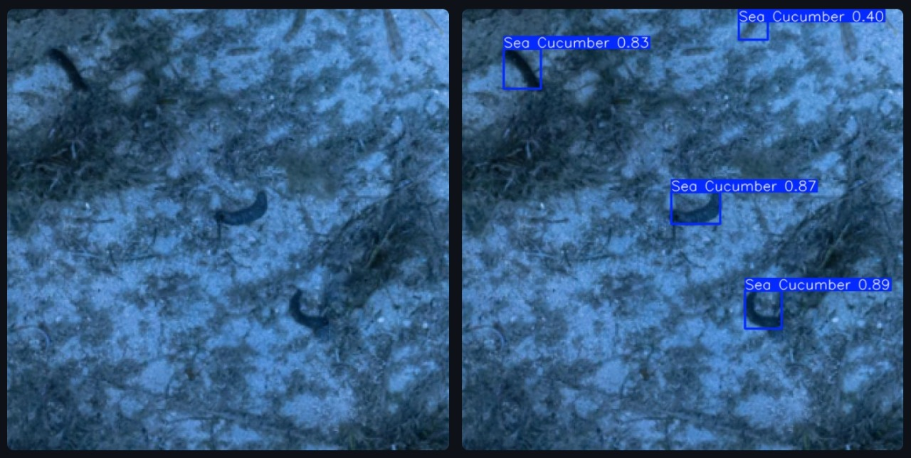

Fig: Detected output

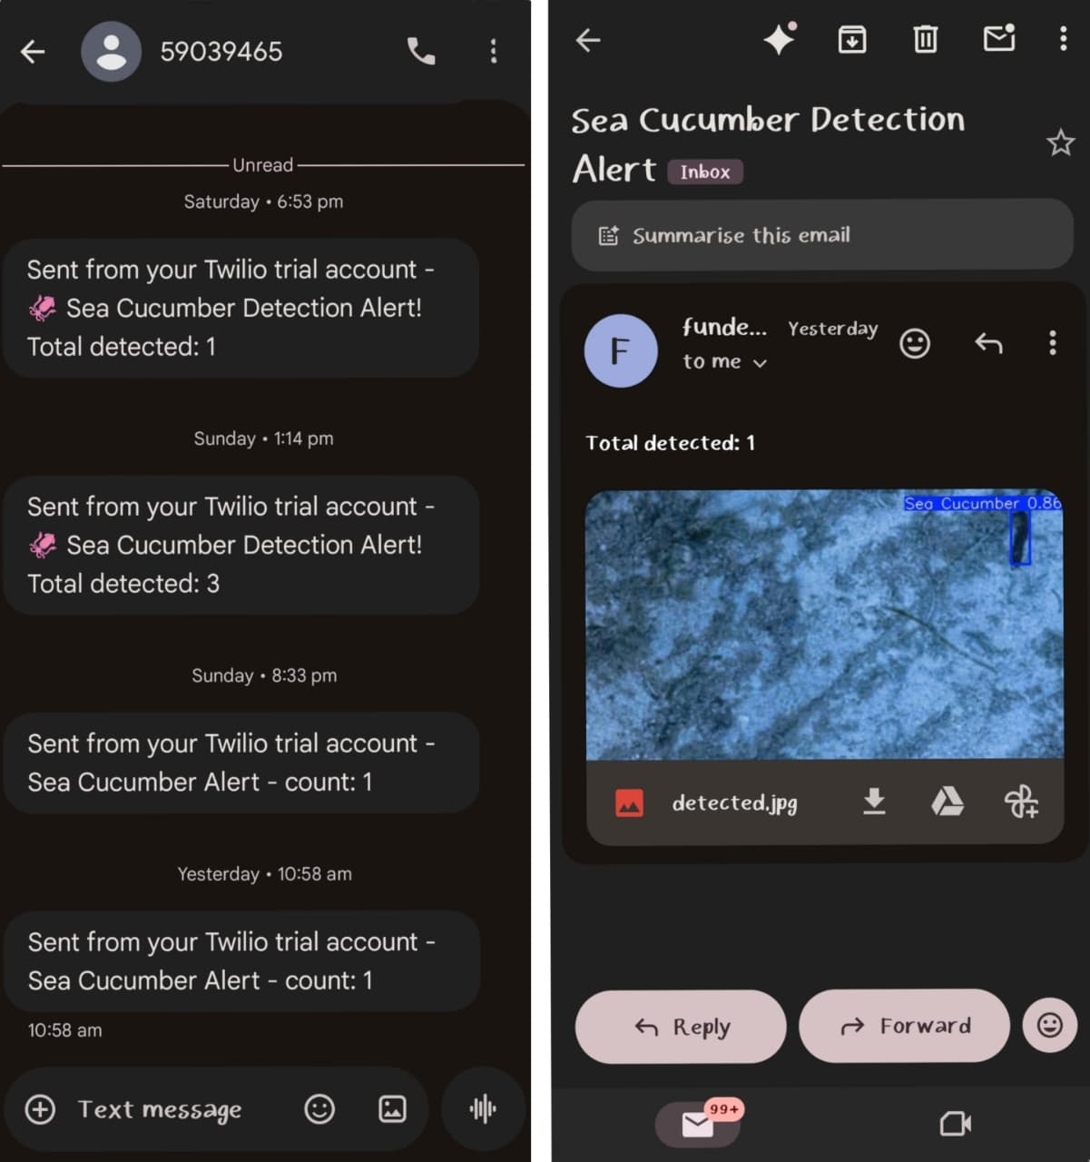

Fig: SMS and Email Alerts

REFERENCES:
- Redmon J., Divvala S., Girshick R., and Farhadi A., (2016): You Only Look Once: Unified, Real-Time Object Detection. Proc. IEEE Conf. on Computer Vision and Pattern Recognition, 1 Las Vegas, NV, 779–788.
- Jocher G., Chaurasia A., and Qiu J., (2020): YOLOv5 by Ultralytics. Ultralytics Repository.
- Ancuti C., Ancuti C.O., Haber T., and Bekaert P., (2018): Enhancing underwater images and videos by fusion. IEEE Transactions on Image Processing, 21(4), 189–197.
- Li C., Guo J., Cong R., Pang Y., and Wang B., (2019): Underwater image enhancement via medium transmission-guided multi-color space embedding. IEEE Transactions on Image Processing, 28(8), 404–415.
- Zhao Z., Zhang H., and Xu Y., (2020): Automatic marine species detection using deep learning. Ocean Engineering Journal, 217, 108–121.
- Islam M.J., Xia Y., and Sattar J., (2020): Fast underwater image enhancement for improved visual perception. IEEE Robotics and Automation Letters, 5(2), 322–329.
- Shortis M., Harvey E., and Abdo D., (2009): A review of underwater stereo-image measurement for marine biology and ecology. Journal of Marine Science, 66(9), 192–203.

